**Oceanographic Suitability Tools**

This is a set of tools to allow a GIS Analyst download oceanographic data and understand what areas of the ocean are suitable for a certain type of fish. The example here is focused on understanding what areas are good for Tuna, but serves as template for other fish types. In fact, the suitability model in this example could be used for understanding suitable areas for other types of analysis as it allows a user the ability to put in values that are not suitable (low value), somewhat suitable (low value to suitable), suitable, somewhat suitable (suitable to high value), not suitable (high value). An example of this is visible below:

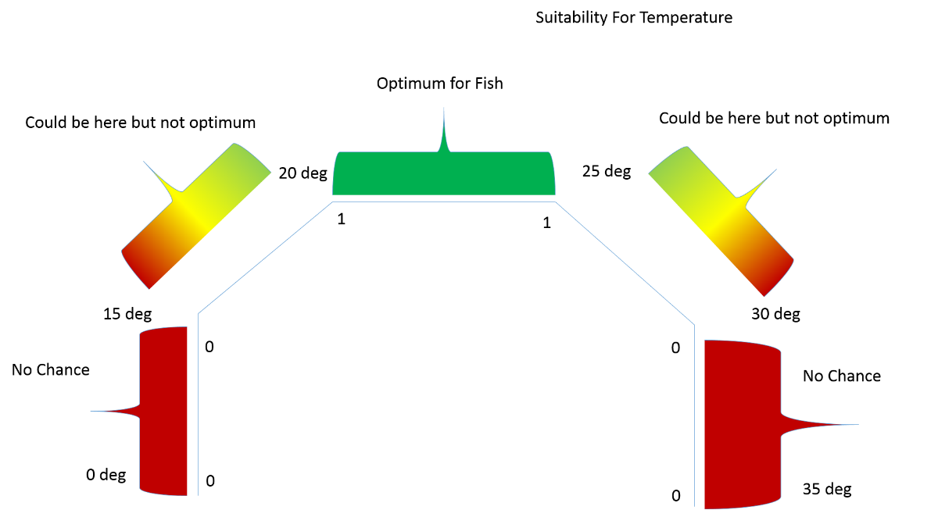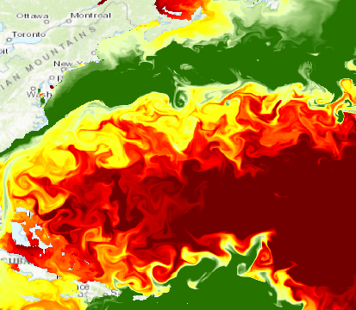

**Geoprocessing Models:**

Suitable Salinity for Fish is a geoprocessing model which takes one salinity raster from the HYCOM multidimensional netCDF data and processes it to find suitable areas. This means that only one salinity raster at one depth and one time can be passed to the model and a suitability output will be created with good, marginal, and poor areas.

Con( "%Input HYCOM Raster%"<= float(%Min Not Suitable%),0,Con("%Input HYCOM Raster%">= float(%Max Not Suitable%),0,Con("%Input HYCOM Raster%"<= float(%Min Lower End Suitable%),("%Input HYCOM Raster%"- float(%Min Not Suitable%))/(float(%Min Lower End Suitable%) - float(%Min Not Suitable%)),Con("%Input HYCOM Raster%">= float(%Max Upper End Suitable%),("%Input HYCOM Raster%"- float(%Max Not Suitable%))/(float(%Max Upper End Suitable%) - float(%Max Not Suitable%)),1))))

**Raster Function:**

Possible solution for suitable salinity (taken from <https://blogs.esri.com/esri/arcgis/2014/08/10/new-multidimensions-in-arcmap/> methodology). This method describes a piecewise suitability model where salinity less than 28.81 ppm(check units) is 0 (not present), any salinity between 32.27 to 35.81 is 1 (optimum suitability), and the groups between 28.81- 32.27 and 35.81 and 36.79 are a fraction of 1. This is example for Tuna, so would have to be adapted per fish species.

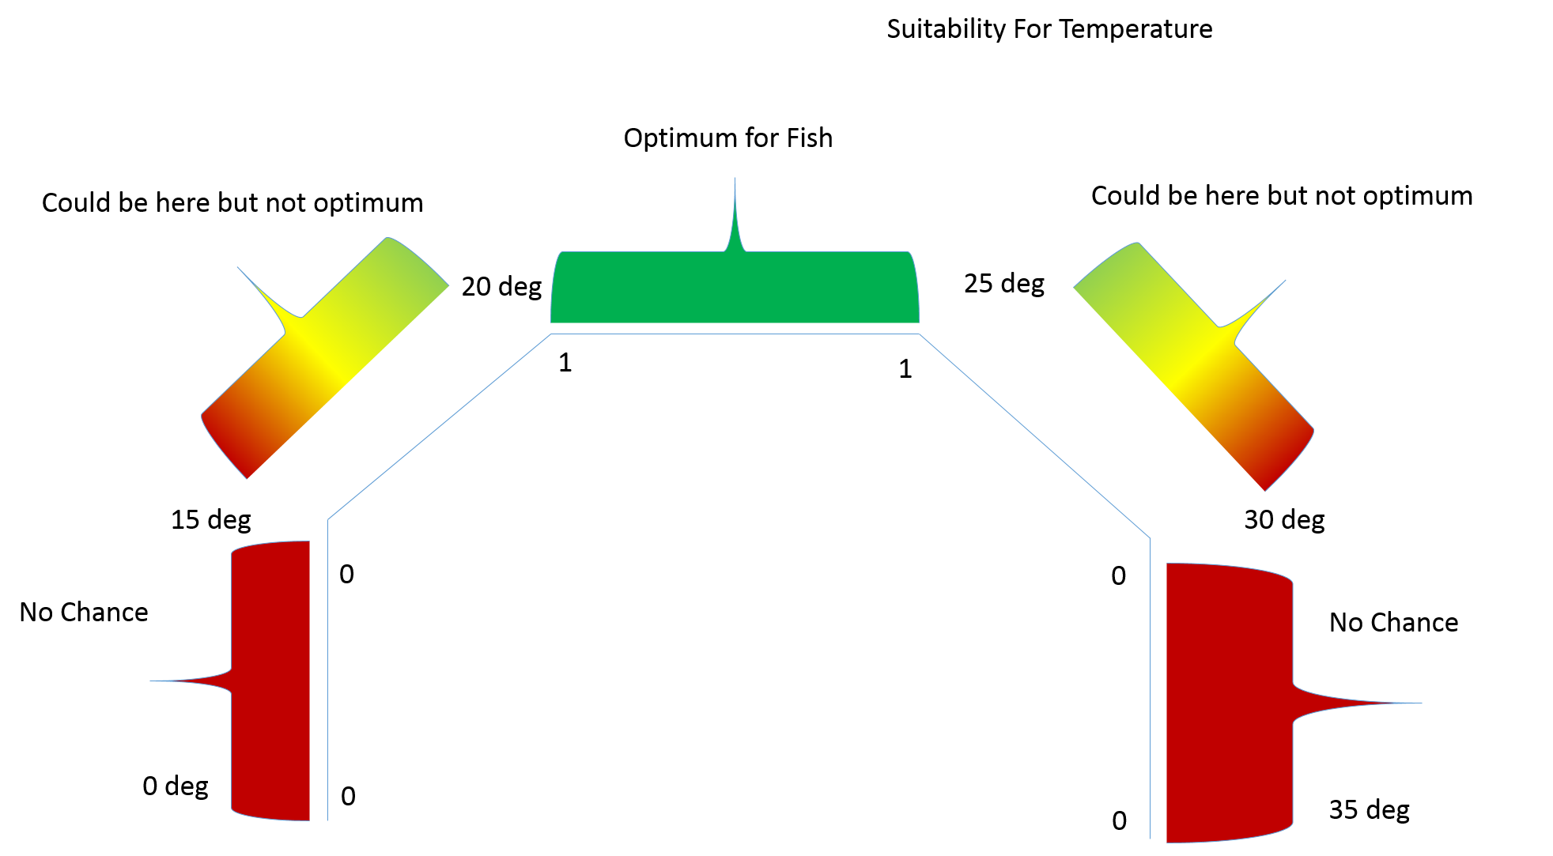

Raster Function for fish suitability

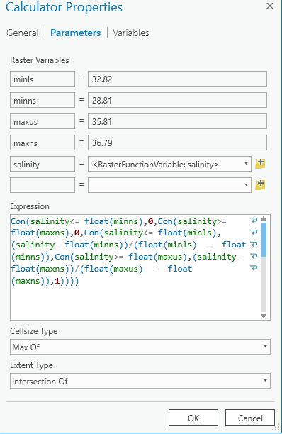

Con(Input HYCOM Raster<= float(minns),**0**,Con(Input HYCOM Raster>= float(maxns),**0**,Con(Input HYCOM Raster<= float(minls),(Input HYCOM Raster- float(minns))/(float(minls) - float(minns)),Con(Input HYCOM Raster>= float(maxus),(Input HYCOM Raster- float(maxns))/(float(maxus) - float(maxns)),**1**))))

**Suitable Salinity Areas with Hard Coded Values**

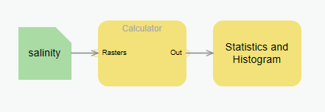

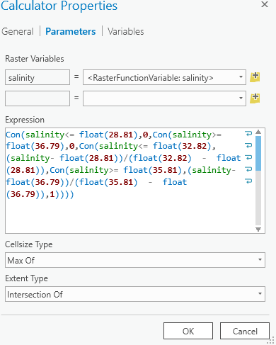

Con(salinity<= float(**28.81**),**0**,Con(salinity>= float(**36.79**),**0**,Con(salinity<= float(**32.82**),(salinity- float(**28.81**))/(float(**32.82**) - float(**28.81**)),Con(salinity>= float(**35.81**),(salinity- float(**36.79**))/(float(**35.81**) - float(**36.79**)),**1**))))

Con(salinity<= float(**28.81**),**0**,Con(salinity>= float(**36.79**),**0**,Con(salinity<= float(**32.82**),(salinity- float(**28.81**))/(float(**32.82**) - float(**28.81**)),Con(salinity>= float(**35.81**),(salinity- float(**36.79**))/(float(**35.81**) - float(**36.79**)),**1**))))

Con("%salinity raster%"<= float(%Min Salinity Not Suitable%),0,Con("%salinity raster%">= float(%Max Salinity Not Suitable%),0,Con("%salinity raster%"<= float(%Min Salinity Lower End Suitable%),("%salinity raster%"- float(%Min Salinity Not Suitable%))/(float(%Min Salinity Lower End Suitable%) - float(%Min Salinity Not Suitable%)),Con("%salinity raster%">= float(%Max Salinity Upper End Suitable%),("%salinity raster%"- float(%Max Salinity Not Suitable%))/(float(%Max Salinity Upper End Suitable%) - float(%Max Salinity Not Suitable%)),1))))

Con("%temperature raster%"<= float(%Min Temp Not Suitable%),0,Con("%temperature raster%">= float(%Max Temp Not Suitable%),0,Con("%temperature raster%"<= float(%Min Temp Lower End Suitable%),("% temperature raster%"- float(%Min Temp Not Suitable%))/(float(%Min Temp Lower End Suitable%) - float(%Min Temp Not Suitable%)),Con("%temperature raster%">= float(%Max Temp Upper End Suitable%),("% temperature raster%"- float(%Max Temp Not Suitable%))/(float(%Max Temp Upper End Suitable%) - float(%Max Temp Not Suitable%)),1))))

"%temperature raster%"